**CONFIRMATORY STRATEGIES – NOTES 2020_09_30**

**TO DO – THIS WEEK**

CLEANING SCRIPT

* Make a batch file to run on Mac (currently it works only for PC)
* Read all the 96 CSV files in the folder (previously there was a problem about that)

SIMULATION SCRIPT

* ~~Familiarize with the structure of the script, changing the parameters alpha/cost…~~
* Save output from simulations EXACTLY as step2_task2 output (all the same columns)
* Save the output files of 3 different models (can call them A, B, C)   
  [keep lambda as it is =parameter of noise in the decision]
* BENCHMARK: Alpha1=alpha2=1, StoppingCost=0
* CONSERVATISM UPDATE: Alpha1=alpha2=0.5, StoppingCost=0
* PREFERENCE FOR CERTAINTY: Alpha1=alpha2=1, StoppingCost=100  
  For each of them, generate output CSV file (looks similar to the output from online experiment)
* Adapt the code for step 1 task 2 to manage the output obtained from the simulation, it should give the same output Step1Task2, save with a different name

ANALYSIS

* Replicate the results from task 2 shown in slide 31 of the slides [also shown below]

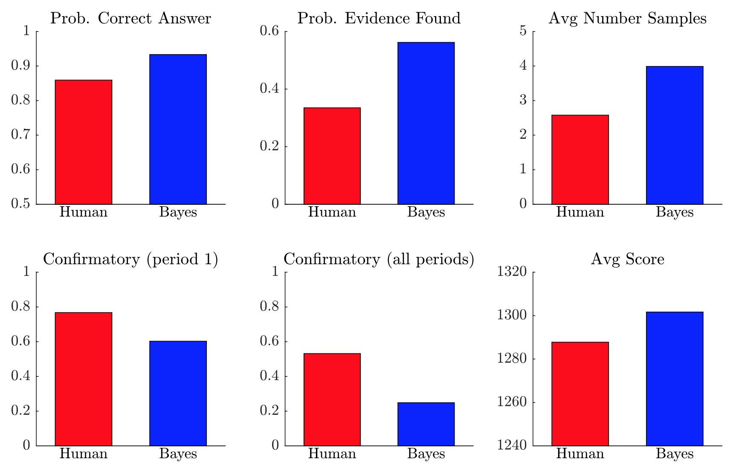

For each of these 6 statistics, just calculate the numerical value (no need to plot, just display in the notebook these six values)

The computations used for these is all in the Matlab analysis folder (under Spring2020 folder)

**NEXT WEEK**

* **Adapt simulation code: give same output as step 2 (directly or after cleaning)**
* Use the simulations to generate the other statistics (predictions=Bayes in the figure)
* Replicate other figures from the Matlab analysis (next: slides 33 and 34)